Standard | Items:
3.NBT.01 -  Use place value understanding to round whole numbers to the nearest 10 or 100. | 2.0  Round 36 to the nearest ten.  Round 52 to the nearest ten.  Round 72 to the nearest hundred.  Round 25 to the nearest hundred.  Round 275 to the nearest ten.  Round 533 to the nearest ten.  Round 198 to the nearest hundred.  Round 742 to the nearest hundred.
3.0
(This is a problem set. Include all 4 on test if using.)

Round 84 to the nearest ten. ______________________

Round 405 to the nearest ten. _____________________

Round 84 to the nearest hundred. _________________

Round 405 to the nearest hundred. ________________

(This is a problem set. Include all 4 on test if using.)

Round 75 to the nearest ten. ______________________

Round 368 to the nearest ten.______________________

Round 75 to the nearest hundred.___________________

Round 368 to the nearest hundred.__________________

3.NBT.02 -  Fluently add and subtract within 1000 using strategies and algorithms based on place value, properties of operations, and/or the relationship between addition and subtraction. | 2.0 (room for work)  Add these numbers.  87 + 54=  Subtract these numbers.  71 - 38=  Add these numbers.  275 + 459=  Subtract these numbers.  632 - 357=  Add these numbers.  63 + 58=  Subtract these numbers.  94 - 35=  Which property of addition helps you find the missing sum?  (7 + 3) + 8= 18 7 + (3 + 8) = ____  - Identity property  - Associative property  - Commutative property  Which property of addition helps you find the missing sum?  12 + 10 = 22 10 +12 = ____  - Identity property  - Associative property  - Commutative property  Which property of addition helps you find the missing sum?  145+ 0=___  - Identity property  - Associative property  - Commutative property  Without solving, which equation do you know has the same sum as 314-176=___?  - 314 + 176 =___  - 176 - 314 = ___  - 176 + ___ = 314  Which equation would help you solve 248 + 474=___?  - ___- 474 = 248  - 474 - 248 = ___  - 248 - 474 = ___  Without solving, which equation do you know has the same sum as 278 + 156= ___?  - 278 - 156 =  - 156 + 278=  - 156 + ___ = 278  Which equation would have the same sum  as (56 + 37) + 26= ___?  - 56 + (37 + 26) = ____  - 56 + 37 - 26 = ____  - 56 - 37 + 26 = ____  Which equation is an example of the identity property?  - 342 + 186 = 186 + 342  - 67 + (56 + 34) = (67 + 56) + 34  - 672 + 0 = 672
3.0 (open-ended- Need room to show work.)
- Add these numbers. Show how you figured it out.

373 + 269 = ______

b. Subtract these numbers. Show how you figured it out.

524 - 186 = ______

3.MD.01 -  Tell and write time to the nearest minute and measure time intervals in minutes. Solve word problems involving addition and subtraction of time intervals in minutes, e.g., by representing the problem on a number line diagram. | 2.0  What time is shown on the clock?  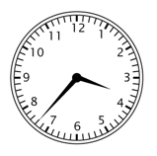  __________________________  2.0 Find the time interval.  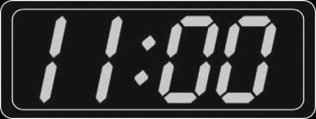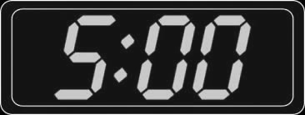  Start Time End TIme  Time interval: ________________________  2.0 Find the time interval.  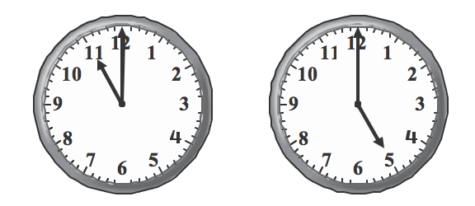
 | 2.0 Jansen’s guitar practice ended at 8:00 AM and was two hours long. What time did his practice start?
3.0a

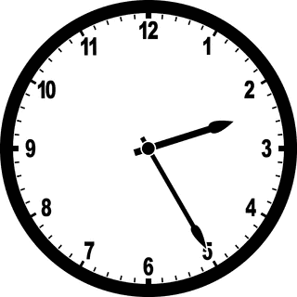 MD.01/3.0

What time will the clock show after 36 minutes?
- 2:41
- 3:01
- 5:38
- 5:47

3.0b A baseball game started at 3:15 PM. Twenty minutes later, Tyler hit a homerun. What time did Tyler hit the homerun?

_________________________________

3.0c Piano class ended at 5:40 PM. Class started 30 minutes before then. What time did the class start?

_________________________________

3.0

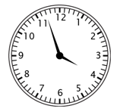
Which of the digital clocks shows the same time?

